**Leader Overview**

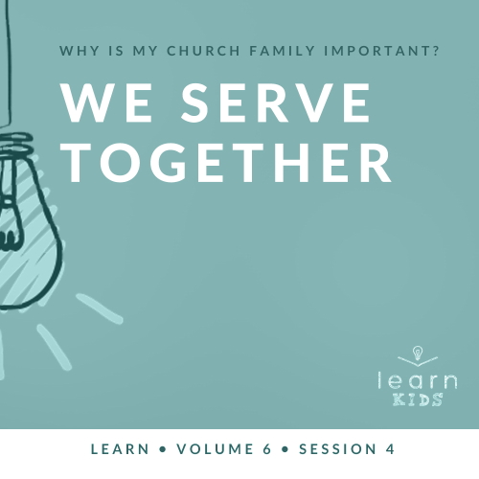

**Volume Overview**

**Why is my church family important?**

*When we think of church, it’s easy for our mind to be instantly drawn to the building where we attend. However, in God’s design, the church isn’t the building that we gather in. Instead, church has everything to do with the people who are gathered there. In essence, the biblical church is not a building that we go to but a family of believers that we belong to*.

*As our Father, God’s heart is to adopt us into His family (*[*Ephesians 1:5*](https://ref.ly/logosref/Bible.Eph1.5)*). When we choose to put our faith in Jesus, we instantly join God’s family. We not only belong to Him, but we also belong to each other. Just like our natural families here on earth were meant to function, God uses our church family to meet our needs. A healthy church family offers love, encouragement, guidance, and accountability. As the family of God—the Church—we grow together, celebrate together, share together, and even serve together. As we make a commitment to God’s family, we will become stronger, more devoted followers of Jesus*.

**Session Overview**

**We Serve Together**

*As God’s family, we must commit to serving each other and the rest of the world. One of the times Jesus modeled serving for us was when He provided lunch for a hungry crowd. Just like the boy who shared his lunch and the disciples who served, God can use our small gifts and talents to meet people’s needs and ultimately lead them to Jesus*.

**Bible Lesson**

Disciples Serve the Crowd

[John 6:1–15](https://ref.ly/logosref/Bible.Jn6.1-15)

**Faith Fact**

We serve together.

**Faith Verse**

[Matthew 18:20](https://ref.ly/logosref/Bible.Mt18.20) (NLT)

“For where two or three gather together as my followers, I am there among them.”

**Preparing for the Session**

**Leader Preparation Time: 20–25 Minutes**

|  |
| --- |
| ***You Will Need***  ***Large Group***   * *Bible* * *Worship songs (Song suggestions: “The Blessing” by Elevation Worship; “The Stand” by Hillsong United; “Broken Vessels” (Amazing Grace) by Hillsong Worship; “This Is a Move” by Bethel Music Worship)* * *For groups not using a phone or tablet only, add:*   *• Projector or TV*  *• Laptop*  *•* ***Faith Fact Slide***  *•* ***Faith Verse Video*** *or* ***Slide***  *•* ***Bible Lesson Video***  *•* ***Teaching Point Slides 1–3***   * *Balloons, twenty in two colors (save to use in Small Group)* * ***Large Group Teaching Time Signs*** *(1–6)* * *Optional: Short, how-to video for something the kids would recognize like a favorite sports move or product* * *Magic towel (small towels that expand in water), one for the leader (Optional: Buy enough to send one home with each kid.)* * *Water* * *Shallow, clear container*   ***Small Group***   * *Bibles for kids in your group to share* * *Balloons, twenty in two colors (saved from the Large Group Game)* * ***Small Group Activity Page****, one per kid* * *Markers*   *To access session content and videos from a computer, visit:* [*BibleEngagementProject.com/downloads*](https://bibleengagementproject.com/downloads) |
| ***Getting Ready***  ***Large Group***   * *Download videos and slides if needed.* * *Select worship song(s) and have them ready to play.* * *Read the Bible Lesson Scripture to prepare for Teaching Time.* * *Inflate the balloons before the session begins.* * *Print the* ***Large Group Teaching Time Signs****.* * *Fill the shallow, clear container with water*   ***Small Group***   * *Inflate the balloons ahead of time or use the ones from the Large Group Game.* * *Print copies of the* ***Small Group Activity Page****, one per kid.*   *First time leading* Learn *for Kids? Check out the* [*Facilitator Guide*](https://0b769b0ed3569ef9d18b-f88d8272f61086866d50d048b43ef630.ssl.cf2.rackcdn.com/sites/biblengagementproject/Listen_Facilitator_Guide.pdf)*.* |

**Large Group**

**30 Minutes**

*See what’s needed at the beginning of the session.*

**Introduction**

I’m so glad you’re here today! Can anyone tell me what the big question we’ve been answering about the church is? *(Allow responses.)* Today, we’ll continue to answer the big question: Why is my church family important? Our church family is important because we grow, celebrate, share, and serve together. Today we’ll talk about serving. Did you know that even Jesus served others when He was on earth? *(Group response)* Jesus is a great example for us of how God expects us to use our talents, our things, and our time to serve others.

**Faith Fact**

I want you to remember that, so today’s Faith Fact is: **We serve together**.

• *Show the* ***Faith Fact Slide***.



Let’s have some fun with our Faith Fact. First, say the Faith Fact with me. **We serve together**. Now let’s do the wave together. Have you ever been at a sports game or watched on TV when the whole crowd takes turns standing up and doing the wave? *(Group response)* Let’s pass the Faith Fact around the room. I’ll start the wave and say the Faith Fact. Those closest to me will go next.

• *Point to indicate who will follow you*.

When it’s your turn to stand, raise your arms up and say the Faith Fact. Ready? **We serve together**.

• *Lead the kids in doing the wave*.

Let’s do the wave one more time and send it in the opposite direction.

• *Lead the kids in doing the wave the opposite direction*.

**Game**

**Serve It!**

|  |
| --- |
| ***You Will Need***   * *Balloons, twenty in two colors*   ***Getting Ready***   * *Inflate the balloons before the session begins.* |

In today’s Bible story, Jesus and His disciples worked together to serve lunch to a lot of people. Let’s see if you can work together to serve. You’ll be serving a little differently than you might think in today’s game.

• *Pick up a balloon and “serve” or hit it to the kids*.

• *Adapt these instructions if your group is not sitting in rows or standing in a line to play*.

Let’s form two teams. One team will be on each side of the room. Each team will have a different color of balloon. Each team needs to choose a disciple who will come to the front and serve your team’s balloons to you. When I say, “Go,” the disciple will begin serving the balloons into the air to your team. Then, everyone on your team needs to serve together to hit or pass the balloons to the back of your team where one team member will serve by collecting them. The first team to serve all ten of their balloons and collect them wins.

• *Play the game and celebrate the winners*.

• *Save the balloons to use in Small Group time*.

You did a great job serving each other in that game. Let’s find out more about serving together.

**Worship**

When we serve with the right heart and attitude, serving can be a humbling experience in a good way. Worship should also be a humbling experience. When we worship God and think about how big and powerful He really is, we realize how small we are. Our big God chooses to spend time with us. He listens to our singing, our prayer, and our praise. He also offers forgiveness to us even though we don’t deserve it. That’s worth worshipping Him for. Let’s sing and worship Him now.

• *Lead the kids in singing one or two praise songs. See suggestions at the beginning of the session*.

**Bible Lesson**

Thanks for worshipping God with me today. We can all be examples to each other of how to become better worshippers of God. Speaking of examples, we’re going to take a look at the best example we could possibly have for serving others. That’s Jesus. First, we’ll pray and then let’s grab our Bible and prepare our heart for what God wants to teach us about serving through His Word today.

**Prayer**

|  |
| --- |
| *Dear God, thank You for giving us the opportunity to serve others. Help us to serve humbly and put others first. Amen.* |

**Video Intro**

Just before we look at the Bible story, let’s watch this video.

• *Play* ***Bible Lesson Video***.

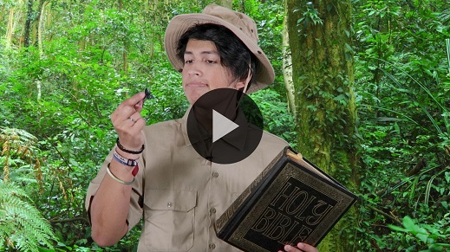

**Bible Story**

**Disciples Serve the Crowd**

That video was such a fun lead-in to our Bible story today. Dash is kind of crazy, isn’t he? *(Group response)* Before Jesus ate the Last Supper with His disciples and died on the Cross, He had an incredible three years of ministry. He did many things that were great examples of His willingness to serve others.

Let’s look at a familiar story about serving others and meeting their needs. Grab your Bible or pull up a Bible app on your device. Then turn to [John 6:1–15](https://ref.ly/logosref/Bible.Jn6.1-15).

• *Read the Bible story aloud to the group*.

• *In order to keep Large Group time moving along, we don’t recommend having the kids read*.

• *Optional: Remind the kids to mark this place with their Bible Bookmark, so they can read it on their own at home*.

**Teaching Time**

|  |
| --- |
| ***You Will Need***   * ***Teaching Point Slides 1–3*** * ***Large Group Teaching Time Signs*** *(1–6)* * *Optional: Short how-to video for something the kids would recognize like a favorite sports move or product* * *Magic towel (small towels that expand in water), one for the leader (Optional: Buy enough to send one home with each kid.)* * *Water* * *Shallow, clear container*   ***Getting Ready***   * *Print the* ***Large Group Teaching Time Signs****.* * *Fill the shallow, clear container with water.* |

Wow! That’s all I can say when I read that Bible story. It never gets old. When you think about it, Jesus performed such an incredible miracle to meet such a simple need. The people were hungry, and He wanted to serve them lunch. Serving one person lunch is no big deal, but can you imagine serving thousands of people lunch at one time? That alone would be a difficult thing to do, but Jesus did it with only five small loaves of bread and two fish.

Jesus gave us a great example of how important it is to serve others. He could have just sent the crowd away to go find their own food. Instead, He chose to serve them so that they could stay and learn from Him. In Matthew’s version of this story, we learn that Jesus also equipped the disciples to serve by giving them the food to give to the people. (See [Matthew 14:19](https://ref.ly/logosref/Bible.Mt14.19).)

Remember what our Faith Fact says? **We serve together**. Jesus didn’t want to be the only one serving the people that day. First, a boy shared his lunch. Then, Jesus had His disciples be involved in serving others. We’re always better when we serve together. Let’s talk a little more about why serving is important and how God wants to use us to serve others.

**1. Jesus is our example for serving people**.

• *Show the* ***Teaching Point 1 Slide***.

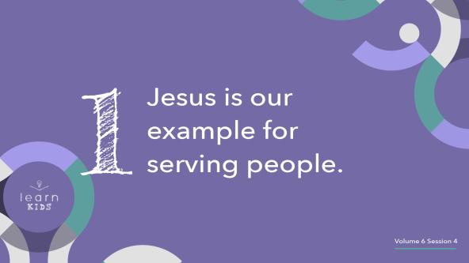

Did you know that pretty much everything you know how to do in life you learned from someone else? *(Group response)* Someone taught you or you watched someone else doing it. You might not even remember how you learned it, but someone else was probably a part of the learning process. Now, we even love to watch how-to videos on our phones and devices for everything. We learn how to fix things, do skateboard tricks, cook a yummy recipe, and even how to beat a video game from the examples we see.

• *Optional: Show a brief, fun tutorial video*.

How-to videos are great and can be a lot of fun, but when it comes to serving, the best possible example for us to look at is Jesus. There isn’t a tutorial video out there that can compare to the example Jesus set for us. Jesus is the perfect example for serving people. We can learn how to serve others by following Jesus’ example. Jesus didn’t need to serve others. In fact, He deserved for everyone else to serve Him. Jesus is God after all. So why do you think Jesus served then? *(Allow responses.)*

Jesus served because He loves people. He also wanted to give us the perfect example of what serving others should look like. If Jesus, who is God, served others, then we should definitely serve others.

**2. God can use your gifts to meet the need**.

• *Show the* ***Teaching Point 2 Slide***.

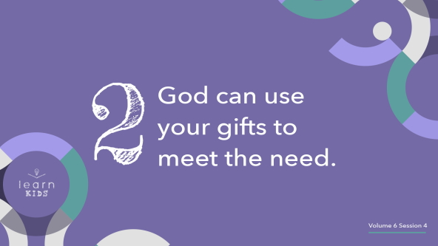

It can be easy to look at what we have and think it’s just not enough. You might look at your talent and think that it’s nothing compared to your friend’s talents. You might look at the things or money you have and think it’s a lot less than what other people have. Why would God want to use you to serve others when there are people who seem to be better and have more? God loves working with what we have so that He can work through us.

That’s exactly what He did with the young boy’s lunch. It wasn’t even close to big enough to feed that huge crowd, but God made it enough. When we don’t have enough on our own, that’s when God is able to use us the most. How is that possibly true? Imagine this tiny shape is you.

• *Hold up the magic towel before it has been dampened*.

This might not look like much right now. Like the boy’s lunch, it’s something that can become a lot more. Our talents, things, and time may be small, but God can use them to meet the biggest needs. If we’re willing to serve with God’s help, He can use our gifts to make a difference. That’s like what happens when I place this small thing in some water.

• *Place the magic towel in the shallow container filled with water. Show the kids how it expands into a towel*.

• *Pull the towel out of the water, wring it out, and show the kids*.

When we allow God to multiply what we have to meet others’ needs, amazing things can happen. Isn’t that exactly what Jesus did with the boy’s small lunch? *(Group response)* When that happens, we need to make sure He gets the glory and the credit.

**3. Serving others points them to Jesus**.

• *Show the* ***Teaching Point 3 Slide***.

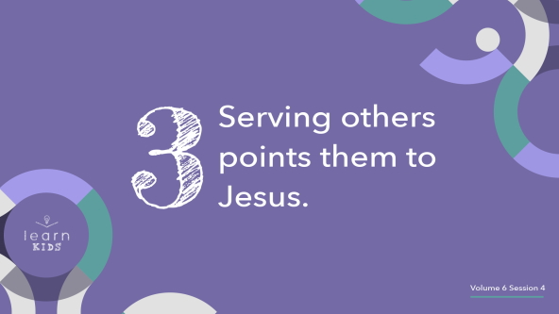

Why should we serve others? *(Allow responses.)* One big reason we serve is to point people to Jesus. When we use our talents and gifts to serve others, our serving should show Jesus’ love for them. Let’s take some time to talk about what serving is and isn’t. First, I need six volunteers to come up and help me.

• *Choose six kids to each hold a sign behind their backs. They shouldn’t show the signs to the rest of the kids until you point to them*.

I need your help. When I say what sharing is, I want you to give me two thumbs-up. *(Demonstrate the action.)* When I say what sharing isn’t, I want you to give me two thumbs-down. *(Demonstrate the action.)* If we decide one of the statements isn’t true about sharing, that volunteer will put down their sign and stand on it to remind us not to do it. Let’s get started.

• *Point to the kid holding* ***Sign 1***.

Serving is about you. Thumbs-up or thumbs-down? *(Group response)* Thumbs-down! When you make serving about yourself, you take away the whole purpose of serving.

• *Volunteer puts down* ***Sign 1*** *and stands on it*.

• *Point to the kid holding* ***Sign 2***.

Serving is about Jesus. Thumbs-up or thumbs-down? *(Group response)* Thumbs-up! Remember, the point of serving is to point people to Jesus, not attract attention to ourself.

• *Point to the kid holding* ***Sign 3***.

Serving is about having a right attitude. Thumbs-up or thumbs-down? *(Group response)* Thumbs-up! It’s not about how much you do or give. It’s about why you’re doing it in the first place. You can serve more than others, but if your attitude is wrong, your serving doesn’t matter.

• *Point to the kid holding* ***Sign 4***.

Serving is only about what you do. Thumbs-up or thumbs-down? *(Group response)* Thumbs-down! This might sound weird because you do things when you serve. The boy gave his lunch. The disciples handed out the food. What we do is not the point of serving.

• *Volunteer puts down* ***Sign 4*** *and stands on it*.

• *Point to the kid holding* ***Sign 5***.

Serving is about the reward. Thumbs-up or thumbs-down? *(Group response)* Thumbs-down! If you’re thinking about what you’re going to get from serving, your focus is wrong.

• *Volunteer puts down* ***Sign 5*** *and stands on it*.

• *Point to the kid holding* ***Sign 6***.

Serving is about following God’s plan. Thumbs-up or thumbs-down? *(Group response)* Thumbs-up! It shouldn’t matter if you get what you want out of serving. It’s all about following God’s plan and direction. If you know He has told you to do it, that’s all you need to know. Let’s thank our volunteers.

• *Lead the kids in clapping as the volunteers are seated*.

**Prayer and Response**

*Consider playing a worship song softly in the background while kids pray*.

One of the ways we can serve each other is by praying together. This might be stepping out of the comfort zone for some of you, but I want to challenge you to do it anyway. Find one or two other people to pray with and ask them how you can pray for them. Take a few minutes to each pray aloud for one another’s needs. Then I’ll pray.

• *Give kids time to pray*.

**Prayer**

• *Optional: Have the kids repeat phrases of the prayer after you*.

|  |
| --- |
| Dear God, thank You for being here with us like our Faith Verse promises. Thank You for giving us the example of Jesus to follow. Help us to serve others like Jesus did with the right attitude and intentions. Amen. |

**Faith Verse**

Sometimes we read about Jesus and probably wish we could have seen Him in person. The disciples were definitely blessed to be able to see His ministry up close and personal.

We can have a personal relationship with Jesus today. We may not be able to see Him with our eyes, but we know He is with us. Our Faith Verse promises that. Let’s review the actions now.

• *Play* ***Faith Verse Video***.

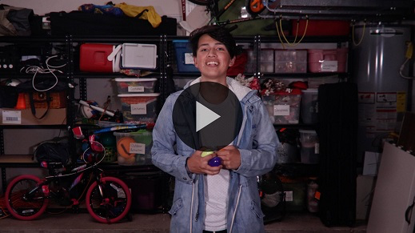

[Matthew 18:20](https://ref.ly/logosref/Bible.Mt18.20) (NLT)

“For where two or three gather together as my followers, I am there among them.”

Aren’t you glad that God’s presence is still available to us even though Jesus isn’t here physically? We don’t always notice Him, but God is with us.

**Faith Fact**

Before we go to our small groups, let’s review our Faith Fact one more time.

• *Show the* ***Faith Fact Slide***.



Say it with me. **We serve together**. We can serve together in our small groups by listening well and participating in the conversation and activities.

• *Dismiss kids to Small Group time or to go home if your group time ends here*.

**Small Group**

**30 Minutes**

*This section can be done in conjunction with the large group or on its own if you do small groups with your kids. During Small Group time, the goal is to connect the kids with the Word of God and to each other. All activities are led by the small group leader.*

**Group Connection**

**Talent Show**

Do you know that God gave each of us different gifts and talents? It’s easy to fall into the trap of comparing our talents to someone else’s. We have different talents so that we can serve together. We need to keep our focus on God and remember that He gave us our talents for a reason. Serving God together is better than any of us could do on our own. We’ll take time today to showcase our talents and thank God for giving them to us. Let’s see some of the talents God has given you.

• *Have kids share about a talent they have and an idea of how they can use it to serve others*.

• *If time allows, let kids share their talent with the rest of the group. Set a time limit like thirty seconds for each kid to share their talent*.

You have some incredible talents! Let’s all take a moment and thank God for the gifts and talents He has given us.

**Learn about It**

|  |
| --- |
| ***You Will Need***   * *Bibles for kids in your group to share*   *No prep needed for this activity.* |

**Scripture Search:** [**Mark 10:45**](https://ref.ly/logosref/Bible.Mk10.45)**;** [**1 Peter 4:8–11**](https://ref.ly/logosref/Bible.1Pe4.8-11)**;** [**Hebrews 6:9–12**](https://ref.ly/logosref/Bible.Heb6.9-12)**;** [**Galatians 5:13–17**](https://ref.ly/logosref/Bible.Ga5.13-17)

Let’s see what else God’s Word has to say about the importance of serving. As we find and read each of these verses, let’s consider: What does this Scripture mean for our life today?

• *Give each kid a Bible and search for one or more of the Scriptures as a group together (as time allows). When everyone has found the Scripture, have one of the kids read it. Then, answer the questions about it*.

• *Pair kids who need additional help with older kids or start simple and look up the session’s Bible story Scripture:* [*John 6:1–15*](https://ref.ly/logosref/Bible.Jn6.1-15)*. Kids will get better finding Scriptures the more they practice*.

• *Optional: Make this a competition to see who can find the Scripture first*.

**Bible Reading Tip**

Are you excited to spend time in God’s Word every day, or has it become more like homework you have to do? *(Allow responses.)* It’s okay to be honest! Even adults struggle with spending time in their Bible every day. When you start to feel that way, it’s time to switch things up. Try switching up the time you’re reading. If you usually read your Bible at night, try switching to the morning. Try switching up your location. If you usually read your Bible in your bedroom, go outside for a change. If you feel like you’re bored reading a certain part of the Bible, choose a different book of the Bible to read. There are always ways to switch things up and keep your time in God’s Word exciting and fresh.

**Challenge**

God has called us to use our talents to serve Him and others. You might already be serving, but it’s even better when you’re intentional about it. What do you think it means to serve intentionally? *(Allow responses.)* When you serve intentionally, you choose something specific to do for someone else, and then you do it. Instead of just saying that you’ll serve others, you could decide, for example, to serve your mom by doing the dishes for her every night this week without her asking you to do them. That’s an example of an intentional way to serve someone.

Our challenge is to choose someone to serve this week. Then, choose something specific you’re going to do to serve them.

**Faith Fact**

Jesus didn’t come to earth and do ministry alone. He chose twelve disciples and other followers to serve with Him. We can also find people to serve with, especially those who are a part of our church family. Remember what our Faith Fact says? **We serve together**.

**Group Discussion**

*Feel free to use all or just a few questions as a jumping-off place for good discussion. Questions marked with * are designed for more conversation. Adjust the questions based on the age or maturity of your group. Typically, older kids will be able to dive a little deeper than younger ones*.

**Questions**

• *If small group activities are not immediately following large group time, you may want to read the Bible story passage before this discussion*.

How many people were in the crowd that Jesus wanted to feed?

Who helped Jesus feed the crowd?

* What’s something else Jesus did in the Bible to serve others?

What’s something your parents or another adult does to serve you?

* Who do you know who is a great example of serving? Why do you say that?

* Why do you think God gives us all different talents?

Have you ever wanted a talent someone else had? What was it?

* How can you use a talent God has given to you to serve others?

* What does it look like to use a talent God has given you to serve Him instead of doing it for yourself?

**Prayer Requests**

*Finish group discussion by sharing prayer requests and praise reports. Keep track of your small group’s prayer requests and review them each time you meet*.

**Prayer**

*Have kids pray for each other’s prayer requests*.

**Faith Verse Review**

|  |
| --- |
| ***You Will Need***   * *Balloons, twenty per group (use the balloons from the Large Group Game)*   ***Getting Ready***   * *Inflate the balloons ahead of time or use the ones from the Large Group Game.* |

Our Faith Verse is [Matthew 18:20](https://ref.ly/logosref/Bible.Mt18.20). When we gather together each week, we can find ways to serve God together and serve each other.

• *Show* ***Faith Verse Video***.



[Matthew 18:20](https://ref.ly/logosref/Bible.Mt18.20) (NLT)

“For where two or three gather together as my followers, I am there among them.”

Today is the last day for us to work on this Faith Verse together. Say it with me.

• *Say the verse as a group a couple of times*.

**Faith Verse Fun**

**Verse Frenzy**

Who knows the Faith Verse like the back of their hand*? (Group response*) That’s good because you are going to need to focus on something besides remembering the verse in today’s game. I’m going to begin throwing balloons at the group while you’re attempting to say the Faith Verse together. You must keep all the balloons in the air while continuing to say the verse together. If you stop saying the verse or if any balloon hits the ground, the game is over.

• *Have the kids stand in a circle close to each other*.

• *When they begin saying the verse, start throwing balloons into the circle*.

• *Play more rounds if time allows, especially if the group is unsuccessful the first time in completing the verse and keeping all the balloons in the air*.

That was totally insane, but you did a great job keeping all those balloons in the air and saying the Faith Verse together.

**Activity Page**

**What Serving Looks Like**

|  |
| --- |
| ***You Will Need***   * ***Small Group Activity Page****, one per kid* * *Markers*   ***Getting Ready***   * *Print copies of the* ***Small Group Activity Page****, one per kid.* |

We’ve talked about serving together today. What do you think of when you hear the word *serve*? *(Allow responses.)* What are some ways you can serve others? *(Allow responses.)* Those are some great ideas. What’s our Faith Fact? **We serve together.** We’ve been learning about the Church and how God wants us to grow, celebrate, share, and serve together. On your paper, draw a picture of how we can serve together. It could be all of us doing something together or you and one or two other people like our Faith Verse says.

• *Hand out copies of the* ***Small Group Activity Page*** *and markers*.

• *Ask kids to share their serving ideas with the group*.

**Dismissal**

Thanks for showing up and being a part of our church family. We are definitely better when we grow, celebrate, share, and serve together. Let’s pray as we’re moving to time to dismiss.

**Prayer**

|  |
| --- |
| *Dear God, thank You for giving us an amazing church family to serve with. Help us to all do our part to serve Your kingdom. Amen.* |

**Faith Fact Recap**

• *Show the* ***Faith Fact Slide***.



Who remembers our Faith Fact? *(Group response)* That’s right! **We serve together.** Remember, we’re a church family, and we’re better together. See you next time.

• *Send home the* ***Small Group Activity Page*** *and magic towel (optional)*.

• *Remind parents that there are* ***Family Devotions*** *available on the app to do with their kid*.

• *Tell everyone the date and time for the next session*.